Smart Cartography for Sustainable Development
31st International Cartographic Conference (ICC 2023), 13-18 August 2023, Cape Town, South Africa
https://icc2023.org/
Call for abstracts and papers
The International Cartographic Association (ICA) invites you to share your research, practice and experiences in cartography and GIScience at the 31st International Cartographic Conference (ICC 2023), to be held from 13 to 18 August 2023 in Cape Town, South Africa. Submissions of abstracts (1-2 pages) and full papers (8 pages) in English are accepted, following the respective ICA templates. Abstracts and full papers will be peer reviewed by a minimum of two experts in the field against the following criteria: scientific originality, potential interest to the community, proper documentation of prior work, clarity of presentation, technical correctness and correct use of language. Authors of accepted abstracts and papers will be invited to present their work in English at the ICC 2023, either as oral presentation or as poster. The presenting author must register for the conference. Accompanying persons, who are registered for the conference, will receive one complementary entry to one technical session of their choice, such as to support a speaker when delivering their presentation. Submit your abstract or paper at https://easychair.org/conferences/?conf=icc2023.

Important dates
5 December 2022 Submission of full papers closes
12 December 2022 Submission of abstracts closes
February 2023 Conference registration opens
28 February 2023 Notification of acceptance
8 May 2023 Submission of revised abstracts and papers
15 May 2023 Early Bird registration closes
15 May 2023 Registration deadline for presenters of abstracts, papers and posters
Conference publications
ICC 2023 publications follow the ICA publication regulations. Accepted abstracts and papers that have been revised to address reviewer comments will be published in one of the ICA publications: Abstracts of the ICA, Proceedings of the ICA, Advances of the ICA or International Journal of Cartography. Authors of accepted abstracts have the option to expand their abstract into a full paper of 8 pages for publication in the Proceedings of the ICA. If they opt not to do this, their abstract will be published in the Abstracts of the ICA.
Full papers are accepted for publication in the Proceedings of the ICA or in the Advances of the ICA. Selected papers accepted for the Advances will be invited to submit their papers to the International Journal of Cartography, for inclusion in a special issue.
On submission, authors will be able to indicate whether they would like their abstracts and papers to be considered for a special issue in one of the ICA’s three affiliated journals - Cartographica, Cartography and Geographic Information Science (CAGIS) and The Cartographic Journal. Following the submission of revisions, editors of the affiliated journals will invite authors of selected abstracts and papers with the potential to be developed into a full journal paper to submit a substantially revised and/or expanded paper to a special issue in their journal, to be published in 2024.
Conference theme and topics
The conference theme is Smart Cartography for Sustainable Development. Conference topics are related to ICA Commissions and other topics of interest to the ICA community:
• Art and cartography
• Atlases
• Augmented, virtual and mixed reality in cartography
• Beyond SDIs towards the future geospatial ecosystem
• Cartographic heritage into the digital
• Cartography and children
• Cartography and GIScience for climate change
• Cartography in early warning and crisis management
• Cognitive issues in geographic information visualization
• Crowdsourcing in cartography and GIScience
• Earth Observation and cartography
• Education and training
• Ethical issues in cartography and GIScience
• Generalisation and multiple representation
• Geospatial analysis and modelling
• Geospatial data, analysis and mapping for SDGs
• Geospatial data, analysis and mapping for service delivery
• Geospatial data hubs for SDGs
• Geospatial semantics
• History of cartography
• Informal settlement mapping
• Location-based services
• Map design
• Mapping Africa for Africa
• Map production and geoinformation management
• Map projections
• Maps and graphics for blind and partially sighted people
• Maps and the internet
• Maps for sport and leisure activities, such as trekking cycling and orienteering
• Marine cartography
• Military cartography
• Mountain cartography
• Open data for cartography and GIScience
• Open science in cartography and GIScience
• Open source geospatial technologies
• Participatory mapping
• Planetary cartography
• SDI and standards
• Sensor-driven mapping
• Theoretical cartography
• Standardization in cartography
• Topographic mapping
• Toponymy
• Ubiquitous mapping
• UN GGIM IGIF implementations
• User experience
• Visual analytics
Looking forward to seeing you all in Cape Town next year!
Regards,
Serena
Serena Coetzee (GPr GISc 1245)
Professor and Head of Department Geography, Geoinformatics and Meteorology, University of Pretoria
Geography Building 1-3.7, Hatfield Campus, Lynnwood Road, Hatfield, 0083, South Africa
email: serena.coetzee@up.ac.za · Web: www.up.ac.za/ggm · Mobile: +27 82 464 4294 · Tel: +27 12 420 3823
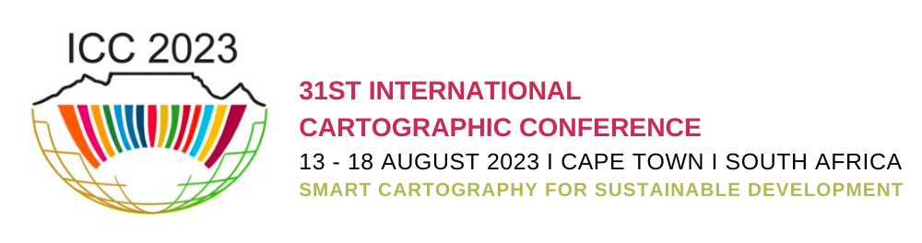

This message and attachments are subject to a disclaimer.
Please refer to http://upnet.up.ac.za/services/it/documentation/docs/004167.pdf for full details.

